Small Drinking Water Systems Operator’s Guide

September 2018

Acknowledgements

The original content of this document was produced by the Southwest Small Drinking Water Systems (SW SDWS) Working Group. Thank you to the following individuals for their assistance in the development and review of the Small Drinking Water Systems Operator Guide:

Kate Beath – Perth District Health Unit
Bryan Cobus – Middlesex-London Health Unit
Walter DiGiovanni – Middlesex-London Health Unit
Allison McIntosh – Southwestern Public Health
Angela Newman – Grey Bruce Health Unit
Fatih Sekercioglu – Middlesex-London Health Unit
Krista Youngblood – Grey Bruce Health Unit

This document is intended for educational purposes only, and is not intended to provide legal advice or replace regulations or other official documents. The SW SDWS Working Group takes no responsibility for any modification of the content of this document.

1st edition

Table of Contents

Introduction 5
Public Health Inspector Responsibilities 7
Risk Assessment 8
Risk Rating 8
Directive 9
Appealing a Directive 9
Compliance Monitoring and Progressive Enforcement 10
SDWS Owner and Operator Responsibilities 12
Owner to Designate an Operator 12
Notification of Intention to Supply Water 12
Treatment 13
Primary Treatment 13
Secondary Treatment 14
Sampling and Testing 15
How to Collect a Water Sample 16
Bacteriological Sampling Requirements 16
Additional Parameters 19
Operational Checks 19
Adverse Events 22
Responding to an AWQI 23
Other Adverse Events 24
Corrective Action 24
Corrective Actions in the Presence of E. coli 25
Corrective Actions in the Presence of Total Coliforms 26
Corrective Actions in the Presence of Improper Disinfection 26
Records Retention 27
Additional Information 29
Well Record Website 29
Resources/Other Training 30
Works Cited 31
Appendices 32

Introduction

This manual is intended to provide an overview of the roles and responsibilities of Public Health Units and owners and/or operators of Small Drinking Water Systems (SDWSs) in Ontario.

In Ontario, drinking water is derived from two sources: surface water and groundwater. Over 80% of SDWSs use groundwater as their water source (Pons, 2015). Groundwater is water below the earth’s surface, found in the spaces between particles of soil, sand, gravel and rock formations. There is a common misconception that groundwater is a safe source of drinking water. There are several potential contamination sources such as poorly constructed wells; malfunctioning septic systems; microbiological (bacteria, viruses, parasites) contamination and chemical (fertilizers, pesticides,) contamination. Groundwater can be evaluated by an environmental assessment, which includes, but may not be limited to, type and location of the well, agricultural activities nearby, and surface runoff after a rain (Sekercioglu, 2018). Consequently, this contamination can lead to illness in the form of vomiting, diarrhea, stomach cramps and/or other complications that may cause death.

In 2000, one of the worst public health disasters in Canadian history occurred in Walkerton, Ontario. Due to bacterial contamination of the municipal water supply, at least seven people died and nearly 2300 became ill. The Walkerton incident became a catalyst for a number of changes in Ontario’s and Canada’s water and wastewater systems (Government of Ontario, 2002).

Until 2008, The Ministry of the Environment, Conservation and Parks (MECP) was the sole regulatory agency for Ontario’s drinking water systems. In 2008 the Ministry of Health and Long-Term Care (MOHLTC) took over the regulatory role of SDWSs. Today, the MECP and the MOHLTC are responsible for overseeing public drinking water systems in the province. Representing the MOHLTC at the local level, Ontario’s public health units regulate SDWS through Ontario Regulation 319. The quality and safety of drinking water of most of Ontario’s municipal water systems is overseen by the MECP through the Safe Drinking Water Act, Ontario Regulation 169 (Water Quality Standards), and Ontario Regulation 170 (Drinking Water Systems).

Enacted in 2008, under the Health Protection and Promotion Act, Ontario Regulation 319 requires SDWS owners and operators to provide the public with safe drinking water at all times and to understand their responsibilities of owning and operating a SDWS. The regulation outlines specific requirements that SDWS owners and operators must comply with such as maintenance of the well, water sampling and testing, and responding to adverse test results. SDWSs are inspected by Public Health Inspectors (PHIs) employed by local public health units who work with SDWS owners and operators to protect the quality of drinking water.

SDWSs under Ontario Regulation 319 include:
- A major residential development, or a trailer park or campground with 6 or more connections and does not operate year round with at least one closure period of 60 consecutive days in every calendar year or every period beginning on April 1 and ending on March 31 of the following year
- A municipal drinking water system that does not serve a major residential development, or a trailer park or campground with six or more connections, and does not serve a designated facility* as defined in Ontario Regulation 170/03
- Large municipal non-residential drinking water systems that serve such facilities as municipally-owned airports and industrial parks, and large sports and recreation facilities
- Small municipal non-residential drinking water systems that serve such facilities as small community centres, libraries, and sports and recreation facilities
- Non-municipal seasonal residential drinking water systems that serve such facilities as private cottages on communal drinking water systems
- Large non-municipal non-residential drinking water systems that serve such facilities as large motels and resorts
- Small non-municipal non-residential drinking water systems that serve such facilities as motels, restaurants, gas stations, churches, and bed and breakfasts

*designated facility includes a children and youth care facility, a children’s camp, a delivery agent care facility, a healthcare facility, a school or private school, a social care facility, and a university, college or other degree-granting institution.

Systems serving designated facilities such as children’s camps, health care facilities, social care facilities, schools, universities, colleges or other degree-granting institutions are not considered SDWSs and fall within the MECP jurisdiction.

Public Health Inspector Responsibilities

Public Health Inspectors are responsible for educating owners/operators on the operation of SDWSs. This can occur during site-specific risk assessments, when directives are being issued or at special educational sessions organized by the local public health unit. The potential risks to users is determined by the PHI during a site-specific risk assessment and inputting observational data and on-site information into a Risk Categorization (RCat) Tool.

PHIs also monitor sampling compliance and results of tests on a regular basis. When adverse water quality incidents (AWQIs) are reported, PHIs follow-up with the owner/operator, provide directions as necessary, and ensure corrective actions are taken. In addition, the Health Unit discloses the results of the risk assessments, the risk level, and any adverse events for SDWS.

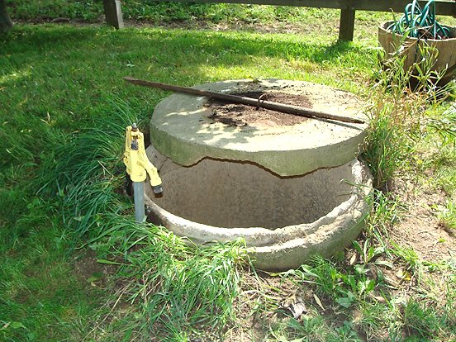
Figure 1: Damaged Lid and Casing
Risk Assessment and Directive

Risk Assessment

Owners/operators are required to be onsite during the risk assessment to provide full access to the system and its components, answer any questions the PHI may have, and provide documentation as required.

The PHI inspects each component of the system including the well, treatment system, and the distribution system, to determine potential risks. This is accomplished by:
- Using the RCat tool to identify and assess potential risks
- Applying a multi-barrier approach to determine any potential risk that may affect the safety of the drinking water. The multi-barrier approach takes all potential hazards into account and takes steps to either eliminate or minimize their impact. It includes protecting the source of the water from contamination, using effective water treatment, and preventing water quality deterioration in the distribution system. (Health Canada, 2013a).

The RCat tool was developed by the MOHLTC specifically for site-specific risk assessments of SDWSs. After inspecting all parts of a system from source water to tap, the PHI inputs the details of the assessment into the RCat program. The program uses a series of weighted questions to generate a risk rating of low, moderate or high and makes recommendations for sampling frequency, well improvement and treatment requirements. The directive is then created from the recommendations, applicable legislation, guidance documents, as well as other pertinent information and the resulting risk level is assigned to the SDWS.

Risk Rating
Risk ratings are obtained through RCat results. The SDWS will be assigned one of the following risk ratings, which determines re-inspection and sampling frequency.

Low | Negligible level of risk, re-inspection every 4 years, low sampling frequency
Moderate | Medium level of risk, re-inspection every 4 years, moderate sampling frequency
High | Significant level of risk, re-inspection every 2 years, highest sampling frequency

Directive

A PHI will conduct a site-specific risk assessment and issue a “directive” for each SDWS outlining the operational requirements that must be carried out by the owner/operator. The directive is a legal document that is specific to each drinking water system, and can include requirements for sampling, testing, treatment, training, and posting signage. Both the owner/operator have a legal responsibility to ensure compliance with the directive and failure to do so may result in legal action. It is important to note the directive is in effect as long as the SDWS is operational, and is still applicable when a new owner or operator is designated. Amendments to the directive can be made, or a new directive can be issued when necessary (e.g. additional treatment).

Appealing a Directive

Section 38 of Ontario Regulation 319/08 allows owners of SDWSs to request a review by the local Medical Officer of Health (MOH) within seven days of a directive or an amendment to a directive being issued. Requests must be in writing and include:
- The sections of the directive or amendment to a directive to be reviewed
- Any submission that should be considered by the MOH
- A current mailing address for the purpose of receiving the MOH’s decision
If you are considering seeking a review, please refer to Ontario Regulation 319/08 for complete details of the review process.

Compliance Monitoring and Progressive Enforcement

Owners/Operators are responsible for ensuring sampling, testing and maintenance of SDWSs is conducted in accordance with directives, applicable regulations and guidelines. Public Health Inspectors monitor compliance by:
- Reviewing water sampling test results and compliance in the Laboratory Results Management Application (LRMA)
- Following up during other public health routine inspections/assessments
- Responding to adverse water quality incidents, complaints and inquiries

Non-compliance means the owner/operator is not following the requirements prescribed by the regulation or directive. Some examples of common non-compliance issues are failure to sample in accordance with the directive, and owners/operators not informing the health unit of changes to their systems.
Typically, progressive enforcement will be used for non-compliance issues found by the PHI during routine inspection, complaints or monitoring sampling compliance. Progressive enforcement begins with a verbal warning, followed by a written warning if compliance is still not achieved, and then the issuance of an offence notice (ticket). Problems are dealt with on a case by case basis, but situations may arise where an offence notice is warranted immediately. For example, if an operator deliberately bypasses a UV system and continues to provide water to users, this would warrant an offence notice. Using the example of a missed sample, below is how all three stages of progressive enforcement may be applied:

- Verbal warning - consists of a phone call or discussion with the operator informing them that a sample was missed
- Written warning - consists of a phone call or discussion with the operator informing them that a sample was missed again, followed by a written letter outlining the legal requirement to sample, the date(s) when a sample(s) was missed, and that the written letter is a warning
- Issuing an offence notice - a set fine for repeatedly failing to sample and comply with the directive
The Set Fines – Schedule 41.2 for Ontario Regulation 319/08 outlines the monetary fines associated with regulatory non-compliance for SDWS owners/operators. The following are a few examples:
- Microbiology sampling — fail to ensure samples tested for E. coli - $295.00
- Microbiology sampling — fail to ensure samples tested for total coliforms - $245.00
- Corrective action — improper disinfection — owner fail to immediately notify MOH - $295.00

SDWS Owner and Operator Responsibilities

Owner to Designate an Operator

Although owners have primary responsibility for the overall operation of the system, they are required to designate an operator who will be responsible for the day-to-day operation including maintenance; sampling and testing; retaining records; and communicating all issues with the Health Unit. This does not remove the responsibility of the owner to ensure compliance with the regulation and the provision of safe water. If an operator is not designated, the owner will be deemed responsible as both the owner and operator. The owner must provide the Health Unit with the name and contact information of the operator, including any time there is a change in owner or operator, to ensure the correct person can be contacted in the event of an AWQI or emergency that may affect the drinking water.

Notification of Intention to Supply Water

If a SDWS has undergone construction, installation, alteration or extension, water cannot be supplied to users of the system until the owner provides the Health Unit with the following information in writing:

- The building permit number issued in relation to the construction or alteration of the SDWS
- Whether or not all the preparations necessary to operate the SDWS in accordance with Regulation 319/08 have been completed and any directives issued have been complied with.
- The proposed date on which the SDWS will begin to supply water to users of the system
- The name and address of the owner and operator
- The address at which the SDWS is located and the name of the system
Prior to the seasonal opening of a SDWS water cannot be supplied to users of the system until the owner/operator has tested water samples for E. coli and total coliforms, has obtained the results, and provided the Health Unit with the following information in writing:
- The proposed date on which the SDWS will begin to supply water to users of the system
- The name and address of the owner and operator
- The address at which the SDWS is located and the name of the system
- The results of the test

The Health Unit requires proof of a water sample result showing no total coliform or E. coli present before the SDWS can supply water to users. If it is a seasonal system (closed for more than 60 consecutive days), the owner must submit to the Health Unit a ‘Notice to Operate or Reopen a SDWS’ form (see Appendix A) along with sample results before opening each year.

Treatment

A site specific risk assessment will determine if treatment is required for a SDWS. If treatment is required, an owner/operator may also be directed to take specific training courses that will address the technical needs of the SDWS. For more information on technical training resources refer to the “Resources/Other Training” section of this guide.

The operator is required to maintain all treatment equipment and ensure all chemical levels are in compliance with the regulation. The type and quality of source water used and the design of the SDWS determines if any treatment is required.

There are two types of treatment: primary treatment and secondary treatment. Examples of systems that may not require treatment include those obtaining water from a secure groundwater source, or systems that are permitted to post warning signs notifying users not to consume the water.

Primary Treatment

Primary treatment kills or inactivates bacteria, viruses and other potentially harmful organisms in drinking water before it is delivered to users. It includes a multi-barrier approach such as filtration and disinfection. Examples include ultraviolet (UV) light and concentration-time disinfection (chlorine).

Concentration time disinfection uses the combination of chlorine and contact time to ensure the system is capable of providing proper disinfection prior to delivery of water to the first consumer.

Ultraviolet treatment systems use ultraviolet light to inactivate or kill bacteria, viruses and cysts in contaminated water. The UV system is also required to have an alarm or an automatic shut-off. The purpose of the alarm is to notify the operator there is an issue with the treatment device and an automatic shutoff will stop directing water to the users if the UV system fails to treat the water.

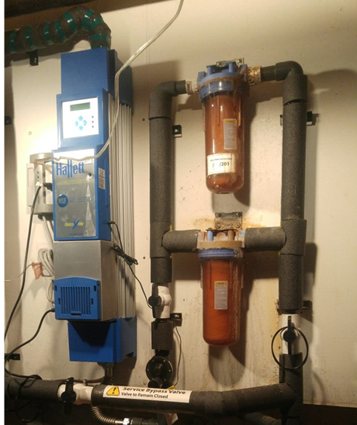
Figure 2: Ultraviolet Light System

Secondary Treatment

Secondary treatment provides water treatment in the distribution system. It involves maintaining minimum disinfection residuals that protect the water from microbiological re-contamination, reduce bacterial re-growth, control biofilm formation, and serve as an indicator of distribution system integrity. Examples of secondary treatment include chlorine, chlorine dioxide and monochloramine. A seasonal campground is an example of a SDWS that requires secondary treatment due to the many connections associated with the system.

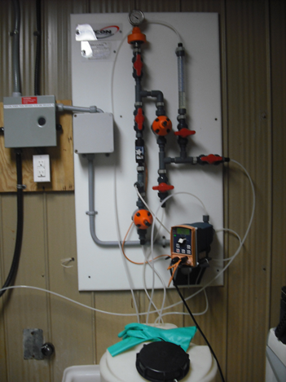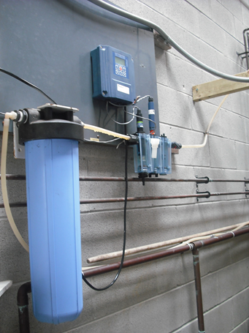
Figure 3: Chlorine Injector Figure 4: Chlorine and pH Monitoring System

Sampling and Testing

Sampling requirements are outlined in the directive issued by the PHI. The SDWS owners and operators are required to have water from their system sampled and tested at an accredited private laboratory licensed by the MECP. Owner/operators must provide written notice to the Health Unit documenting the accredited private laboratory they intend to use by submitting a completed ‘Laboratory Services Notification’ form (See Appendix B). The lab uploads the test results to a database called the Laboratory Results Management Application (LRMA) which the Health Unit can access.

How to Collect a Water Sample

- Use only appropriate bottles supplied by the laboratory.
- These bacteriological sampling bottles have tamper-proof seals. Do not use them if the seal has been broken; ask the lab for a new one.
- Samples should be collected from a cold water tap that is a part of the SDWSs distribution or plumbing system.
- For treated water (i.e. chlorine or UV): sample must be taken after treatment
- For smaller systems: at a kitchen sink or a valve in the plumbing after treatment
- Distribution system samples must be taken where it is representative of the system
- Remove any aerators, tap screens, hoses or filters on the tap.
- Wash your hands or use disposable gloves.
- With an alcohol swab, clean the mouth of the tap. Do not flame the tap.
- Let the water run cold for at least two minutes before collecting the sample.
- Do not rinse the sampling bottle before using (or you will remove the preservative).
- Do not touch the inside or lip of the bottle, or the inside of the cap.
- Fill the bottle to the shoulder (or fill line), leaving an air space. Do not overflow.
- Keep sample cold (refrigerate but do not freeze)
- If shipping the sample, make sure it is packed in ice as soon as it is collected.
- Submit to laboratory shortly after collecting.
- Drinking water samples should be submitted to a licensed lab within 24 hours.
- The earlier the lab receives the water samples, the quicker it can be tested and the more accurate the test results will be.

Bacteriological Sampling Requirements

All SDWSs requiring testing must submit samples for Escherichia coli (E. coli) and total coliforms.

E. coli are fecal bacteria commonly present in human and animal feces. The presence of E. coli in any groundwater sources indicates the groundwater is contaminated by faecal material and is therefore unsafe for drinking without further treatment (Health Canada, 2013b).

Total coliforms are a group of bacteria found throughout the environment. Their presence in well water indicates the groundwater may be vulnerable to contamination from the surrounding environment (Health Canada, 2013c).

Sampling frequency for E. coli and total coliforms is determined from the risk assessment and are dependent upon a number of factors including source water, type and condition of well, and treatment; and can range from weekly to quarterly sampling.

Heterotrophic plate count (HPC), also known as Standard Plate Count, may be used to assess water quality. Heterotrophs are a group of microorganisms (bacteria, moulds and yeasts) that use organic carbon sources to grow and can be found in all types of water. The HPC test can be used to measure the overall bacteriological quality of drinking water.

Table 1 outlines the recommended frequency of bacterial sampling for E. coli and total coliforms for all SDWSs without testing history (Ministry of Health and Long-Term Care, 2018).

Table 1: Recommended Sampling Frequency
Risk Category | Treatment Provided | Frequency of Sampling Water after Being Treated or Otherwise Directed for Consumption
Low | No | One sample every three months
Low | Yes | One sample every three months
Medium | No | One sample monthly
Medium | Yes | One sample every two months
High | No | One sample every week
High | Yes | One sample every two weeks

Table 2 outlines the recommended sampling frequency for SDWSs with distribution systems, by level of risk (Ministry of Health and Long-Term Care, 2018).

Table 2: Recommended Sampling Frequency with a Distribution System
Number of Connections** | Secondary Treatment | Low Risk | Moderate Risk | High Risk
2-10 connections | Yes or No | One sample monthly | One sample monthly | One sample monthly
11-100 connections | Yes | One sample monthly | One sample monthly | One sample every two weeks
> 100 connections | Yes | One sample from the treated water supply AND one sample for every 100 connections or part thereof from the distribution system monthly | One sample from the treated water supply AND one sample for every 100 connection or part thereof from the distribution system every two weeks | One sample from the treated water supply AND one sample for every 100 connections or part thereof from the distribution system every week

**Number of connections is the number of drinking water access points which may either be single or grouped
- Single access point: a single standalone access point which may have one or more spouts, such as a drinking water fountain, a tap, or a trailer park site hook up
- Group access point: refers to a system of plumbing within a single building
It is important to note that these charts are recommendations as there are various factors that influence sampling frequency. Some factors include:
- Water sampling History
- Type of treatment
- Drinking water source – secure groundwater, surface water, etc.
- Complexity of the system
- Identified Risks
- Other samples that may be required e.g. heterotrophic/standard plate count

Additional Parameters
Additional testing is required for any water supply in which a chemical or radiological agent is present or is suspected of being present, either because it is naturally occurring, or is a result of a chemical spill. Examples of chemical or radiological agents include nitrates, pesticides, sodium, and fluoride.

If contaminants are naturally occurring and are not expected to increase, or the test result is below limits specified in the Ontario Drinking Water Quality Standards, repeat testing may not be required. The Ontario Drinking Water Quality Standards sets the maximum acceptable concentrations, aesthetic objectives and operational guidelines for various parameters of drinking water such as taste, odour and turbidity, as well as several different minerals, metals and chemicals that can be present through industrial, commercial, and agricultural processes.
If contaminants have the potential to fluctuate in a manner that may pose a risk to the health of users, regular sampling and testing may be required. As always, remember to follow licensed laboratory instructions to ensure proper collection and submission of samples.

Operational Checks
All owners/operators are required to conduct operational checks of their SDWS at a frequency indicated in their directives, equipment manufacturer guidelines, or as required to maintain the system.
Operational checks include but are not limited to:
- Testing free available chlorine or combined chlorine residual levels
- Measuring turbidity – a measure of the amount of suspended material in water which can impact disinfection processes
- Monitoring the status of equipment i.e. UV system status, filter condition, chlorine solution level
- Conducting well inspections including inspection of the well cover or sanitary seal for cracks and holes; examination of the condition of well vents
- Ensuring all filters and treatment devices are maintained as per the manufacturer’s directions
Where filtration and primary or secondary disinfection is required:
- Chlorine residual should be tested once every 24 hours or as directed by a PHI
- Turbidity should be tested at a frequency in accordance with risk level and system configuration
Ensure water treatment equipment is:
- Operated whenever water is being supplied
- Operated in accordance with the manufacturer's instructions
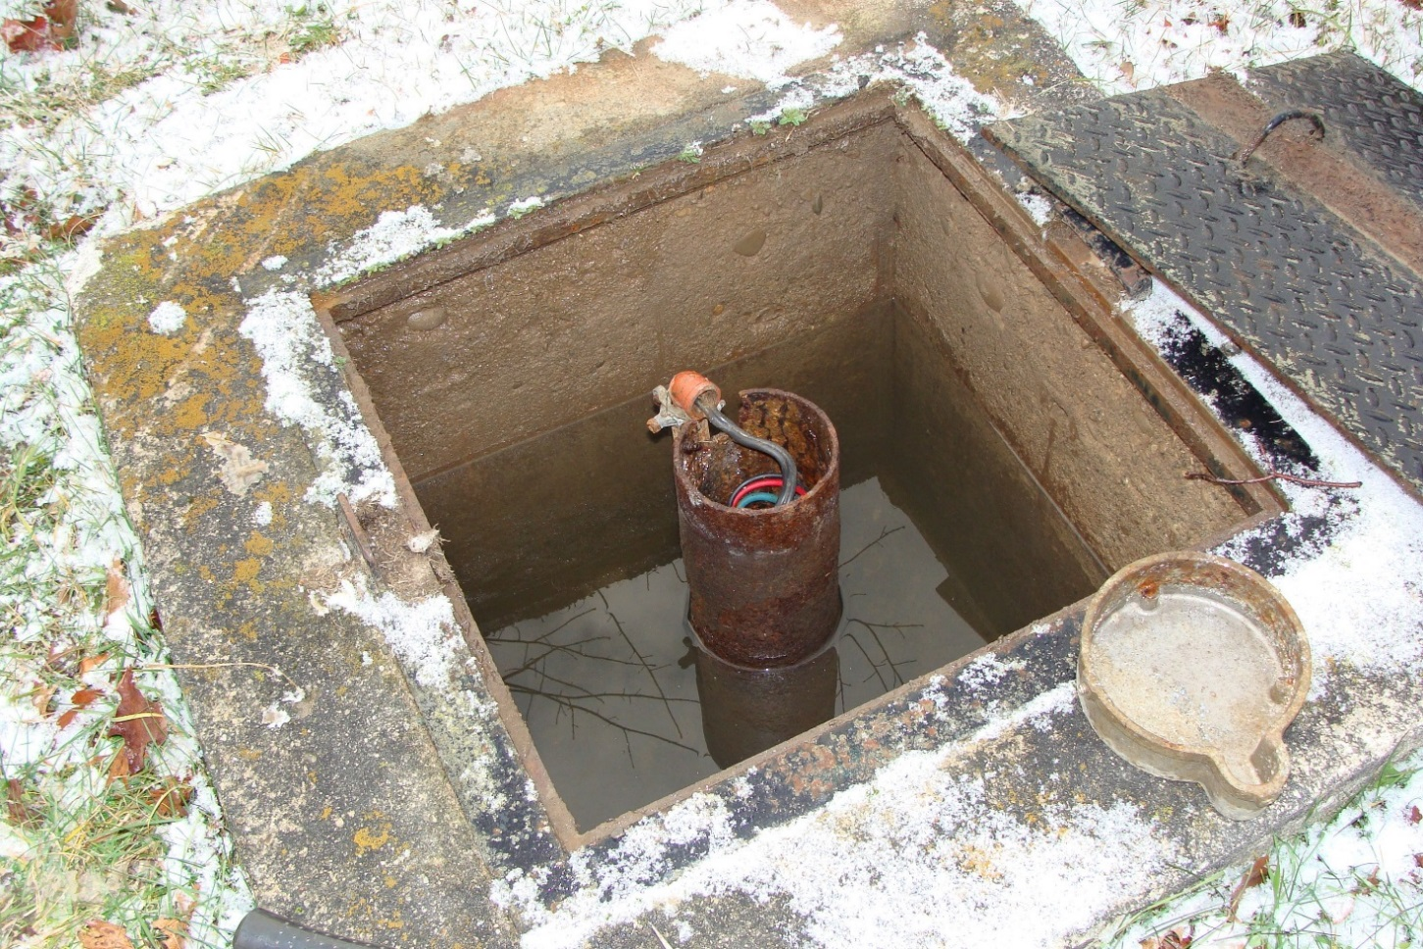
- Operated in a manner that achieves the design capabilities
Figure 5: Potential Surface Water Contamination

Operational Checks for Posted Systems
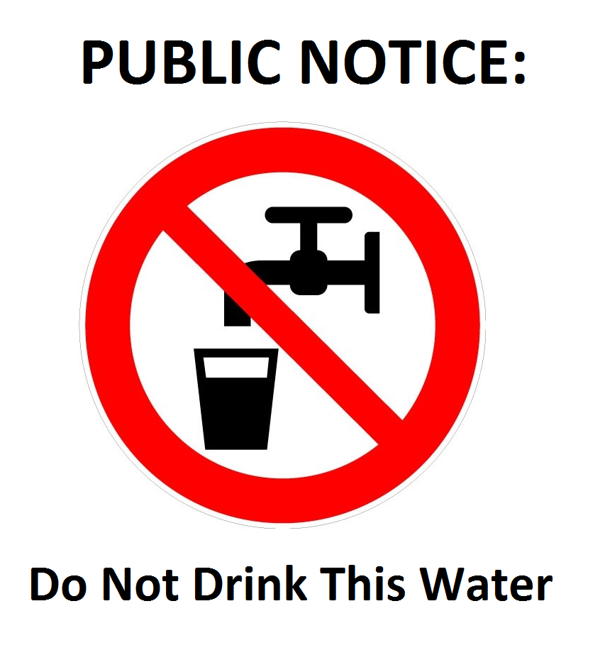
The directive issued by a PHI may require an owner/operator to post and maintain warning signs notifying users not to consume water from the SDWS. Routine checks of signage at all entrances and access points to water are required. This is to confirm signs are posted, in a good state of repair and are easily readable. Even if a system is posted, operators should still be checking the well and other components of the system to prevent contamination of the source water. The frequency of routine checks is determined by your PHI who takes into consideration the type of facility and usage.
Figure 6: Example of Signage for a Posted System

Adverse Events

Adverse events are events that may impact the quality of water supplied to users and include both adverse observations and adverse test results. When an adverse event occurs the owner/operator must notify the Health Unit immediately, and a PHI will assist the owner/operator in determining an appropriate response.

Examples of adverse observations include (may not apply to all systems):
- Inadequate filtration of the water entering the system
  - Example: high turbidity (cloudiness)
- Low disinfection levels in the distribution system
  - Example: below 0.05 mg/L free chlorine or below 0.25 mg/L combined chlorine
- Contamination of the SDWS due to the possibility of back siphonage
  - Examples: low pressure causing backflow, cross-contamination
- Failure of the ultraviolet (UV) disinfection system
  - Example: UV system turns off due to power failure or UV system alarms due to malfunctioning of the system

An adverse test result is a drinking water test result that shows an outcome that differs from what is stated in Ontario Regulation 169/03 (Ontario Drinking Water Quality Standards under the Safe Drinking Water Act, 2002), or from the directive issued to the small drinking water system. Therefore, this is any result of a test or sample that is not within acceptable levels and could cause harm to the health of the users of the system. For example, a test result with total coliform or E. coli would be considered adverse.

When the lab finds results that are not acceptable, they report to the health unit and the operator of the system immediately by telephone. This starts the adverse response and issuing of the adverse water quality incident (AWQI) number, which is used to track the incident.

Examples of adverse test results (may not apply to all systems):
- Microbiological parameters:
  - Presence of total coliforms and/or E. coli
- Chemical or radionuclide parameters:
  - High concentrations of chemicals (e.g. nitrate or lead) or radionuclide (e.g. uranium or radon) in your source water
- Onsite Operational tests
  - Turbidity exceeding 1.0 NTU

Responding to an AWQI

Ontario Regulation 319/08 provides direction for notification and corrective actions for specific adverse events.

Notification:
- Immediately notify the local Medical Officer of Health (MOH) of every adverse observation or test result indicating the system may not be providing safe water
- Notification must be done by speaking to a live-person, it cannot be by voicemail or electronic communication
- You will receive an AWQI number that you must record
- If the adverse event occurred after hours, call the main number and use the on-call system to contact the PHI on duty
- Written notice must be sent to the MOH within 24 hours
- Fill out a ‘Notice of Adverse Test Results and Issue Resolution’ form (Appendix C)

The PHI will discuss the AWQI with you and ensure you are following appropriate corrective actions. They may also put in place extra requirements depending on the incident.

The laboratory and the owner/operator of the SDWS are required to fill out a ‘Notice of Adverse Test Results and Issue Resolution’ form and provide it to the health unit. These must be completed and sent in to the local public health unit within 24 hours of the original incident.

The users of the SDWS may also need to be notified of the adverse event and any actions they must take to protect their health. A PHI will determine if notification is necessary based of the circumstances of the adverse event. To notify users, one of three advisories may be issued:

- Boil Water Advisory (BWA) - issued when there has been bacteriological contamination of water. The user should let water come to a rolling boil for 1 minute before consuming.
- Do Not Drink or Do Not Use Advisory – issued when there has been chemical contamination of water. Water should not be used at all, and an alternate source of water should be used and consumed
- Health Information Advisory – issued, for example, when sodium or fluoride concentrations are excessively high in water. Users should take steps to protect their health.

The SDWS users may be notified by telephone, through media advisories, or door-to-door notification. When required the Health Unit works in conjunction with the owner/operator of the SDWS to ensure all users are notified. Ultimately it is the responsibility of the owner/operator to notify all users of the system.

Other Adverse Events

Not all types of adverse events are captured in the regulation. If any other type of adverse event occurs, notify your local public health unit and follow the necessary steps as directed. Continue to follow the same reporting and resolution procedures.
Examples of other adverse events:
- Chemical spill that enters the source water that supplies your small drinking water system (i.e. diesel or other petroleum-based products)
- Agricultural products that enter your small drinking water system source water either from run-off or by leaching into the aquifer
- Broken pipes or water mains
- Naturally occurring chemical or radiological agents such as nitrate or uranium

Corrective Action
While the regulation details specific corrective actions, it is important to speak with a PHI to discuss any additional requirements that may be necessary. When taking corrective actions, you should:
- Follow the corrective steps outlined in Ontario Regulation 319/08
- Follow the corrective steps outlined in the applicable guidance documents such as
  - Procedure for Disinfection of Drinking Water in Ontario
  - Procedure for Corrective Action for Small Drinking Water Systems that are not Currently Using Chlorine
- Follow the directions provided by your PHI
- Refer to local public local health unit resources
Once all corrective actions have been taken to remedy the problem that caused the adverse event, consult with the PHI and provide a written notice to the Health Unit summarizing:
- Actions that were taken to correct the issue; and
- The water sample results that were achieved
The written notice must be completed on the Notice of Adverse Test Results and Issue Resolution form 480-64E. This is the same form to be completed within 24 hours of the incident. The corrective actions taken should be documented in addition to the results that were achieved. The form must be sent to the health unit within 7 days after the issue has been resolved.
Some common adverse events that require corrective actions include:

Corrective Actions in the Presence of E. coli
Presence of E. coli in drinking water indicates that fecal contamination may have occurred, and that disease causing organisms may be present. The number of E. coli present in drinking water should always be zero.
When E. coli is present:
- Immediately notify all users of the drinking water system:
  - To use an alternate source of drinking water or, if none is available,
  - To bring their water to a rapid, rolling boil for at least one minute before use
- Immediately resample and test
- For a SDWS using chlorine:
  - Immediately increase the chlorine dose to 0.2 mg/l FAC and flush the system to ensure there is an adequate chlorine residual of at least 0.5 mg/l.
  - Maintain residual until two consecutive water samples taken 24 - 48 hours apart are free of E. coli. Sample according to your Health Unit directions.
- For a SDWS not using chlorine:
  - Immediately follow the steps for temporary disinfection of the system as required by the health unit
    - Refer to the ‘Procedure for Corrective Action for Small Drinking Water Systems that are not Currently Using Chlorine’
If the operator does not take the appropriate steps to protect users, the PHI will issue a Boil Water Advisory. The owner and/or operator of the system would likely be charged for failing to adhere to regulatory requirements.

Corrective Actions in the Presence of Total Coliforms
Presence of total coliforms in drinking water indicates the integrity of the water system may be compromised, even though disease-causing organisms may not be present. The number of total coliforms in drinking water should always be zero.
When total coliforms are present:
- Resample and test as soon as possible
  - Additional actions may be required, such as disinfecting the system, based on a risk assessment by a PHI
- If after resampling, total coliforms were still greater than 0:
  - For a SDWS using chlorine:
    - Immediately increase the chlorine dose and flush the system to ensure there is adequate chlorine residual. Maintain the residual until two consecutive water samples taken 24 - 48 hours apart are free of total coliforms
  - For a SDWS not using chlorine:
    - Immediately follow the steps for temporary disinfection of the system as required by the health unit
      - Refer to the ‘Procedure for Corrective Action for Small Drinking Water Systems that are not Currently Using Chlorine’

Corrective Actions in the Presence of Improper Disinfection

Improper disinfection indicates that there may be a breach in the SDWS or a failed UV system; that the disinfectant treatment process is not functioning sufficiently to maintain an adequate level of disinfectant; or there could be a system malfunction or change in source water. However, every situation is different.
In these situations, you should:
- Immediately restore the disinfection
- Immediately notify and instruct all users of the drinking water system to use an alternate source of drinking water or, if none is available, to bring their water to a rapid, rolling boil for at least one minute before use
- Continue to boil water until the system has restored disinfection, all public health requirements have been satisfied and you have consulted with the PHI

Records Retention

All records relating to the SDWS must be kept on site for 5 years and must be made available to the public and the PHI if requested.

Examples of records include:
- Water Sample Records
- Adverse reports
  - E. coli >1 and/or total coliforms >1
  - Overgrown
  - Chlorine level < 0.05 mg/L
  - Pressure loss
  - UV light malfunction
  - Chemical or radiological test results (if required by directive)
  - Directives
- Ontario Regulation 319/08
- Operational checks
  - Chlorine residuals
  - Turbidity
  - Signage checks (for posted systems)
- Maintenance on system
  - Pump repairs/replacements
  - UV bulb and filter replacements
- Operator manuals
- Any other relevant information

It is a good idea to keep all the records in one place, such as in a binder, to ensure the information can be readily accessed by anyone who needs it. You may also want to develop a chart outlining the different types of required operational checks and their frequency.
Operators should also maintain a record keeping log to document every instance in which the SDWS was checked or inspected to ensure it was in good working order. The log should include the date and time the check was completed, the results of the check and what actions were taken, if any, and the signature or initials of the person who completed the check.

Operator Training

Training for operators ensures they are aware of their responsibilities under the regulation and have the knowledge required to maintain a safe supply of water to the users of the system.
The owner is responsible for ensuring proper training is provided to operators. The operator should be knowledgeable of the system in order to respond appropriately to adverse events or other conditions that may affect the safety of the water. The PHI will determine whether the type of training the operator has is appropriate and may recommend additional training. Training is dependent on the complexity of the system as well as the results of the risk assessment.

Training requirements may include:
- Personal consultation with a PHI
- Training provided by your local public health unit
- Training provided by equipment or treatment system providers
- Other approved training provided by the Ministry of Environment Conservation and Parks or Walkerton Clean Water Centre

Additional Information

Well Record Website

The MECP has created a database of reported wells in Ontario to access well record information. Well record information includes the depth of water within the well, depth of casing, materials used to construct the well, and the well diameter. The information may assist in well maintenance and responding to adverse events. When possible, the well record should be made available during the risk assessment. Wells installed before 2002 were not subject to many of the regulatory requirements currently in place, and may not have a well record or could have missing information. The database can be accessed at https://www.ontario.ca/environment-and-energy/map-well-records
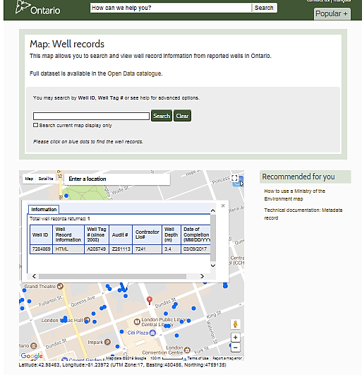
Figure 7: Online Well Records

Resources/Other Training

- Ontario Regulation 319/08 (Small Drinking Water Systems)
- The MOHLTC SDWS information kit
- Public Health Inspector
- Guidance documents:
  - Procedure for Disinfection of Drinking Water in Ontario
  - Procedure for Corrective Action for Small Drinking Water Systems that are not Currently Using Chlorine
- Other local health unit
- Walkerton Clean Water Center https://www.wcwc.ca/en
- The Ministry of Environment Conservation and Parks website
- Local public health unit websites
- Ministry of Health and Long-Term Care (MOHLTC) - Safe Drinking Water and Fluoride Monitoring Protocol, 2018 http://www.health.gov.on.ca/en/pro/programs/publichealth/oph_standards/docs/protocols_guidelines/Safe_Water_Fluoride_Protocol_2018_en.pdf
- Walkerton Clean Water Centre https://www.wcwc.ca/en/
- Ministry of Environment and Climate Change (MOECC) - Drinking water https://www.ontario.ca/page/drinking-water
- Sir Fleming College - Wells and Water Systems Course https://flemingcollege.ca/continuing-education/courses/wells-and-water-systems
- Source water protection http://home.waterprotection.ca/
- E-laws https://www.ontario.ca/laws
- Ontario Drinking Water Quality Standards https://du0tsrdospf80.cloudfront.net/docs/030169_e.doc
- Public Health Ontario Chlorine calculator https://www.publichealthontario.ca/en/ServicesAndTools/Tools/Pages/Dilution-Calculator.aspx

Works Cited

Government of Ontario (2002). The Walkerton inquiry. Retrieved from http://www.archives.gov.on.ca/en/e_records/walkerton/index.html

Health Canada (2013a). The multi-barrier approach to safe drinking water. Retrieved from https://www.canada.ca/en/health-canada/services/environmental-workplace-health/water-quality/drinking-water/multi-barrier-approach-safe-drinking-water-environmental-workplace-health-health-canada.html

Health Canada (2013b). Guidelines for Canadian drinking water quality: Guideline technical document – Escherichia coli. Retrieved from https://www.canada.ca/en/health-canada/services/publications/healthy-living/guidelines-canadian-drinking-water-quality-guideline-technical-document-escherichia-coli/page-2-guidelines-canadian-drinking-water-quality-guideline-technical-document-escherichia-coli.html#a21

Health Canada (2013c). Guidelines for Canadian drinking water quality: Guideline technical document – Total coliforms. Retrieved from https://www.canada.ca/en/health-canada/services/publications/healthy-living/guidelines-canadian-drinking-water-quality-guideline-technical-document-total-coliforms/page-2-guidelines-canadian-drinking-water-quality-guideline-technical-document-total-coliforms.html#a2.1

Ministry of Health and Long-Term Care (2018). Small drinking water systems risk assessment guideline. Retrieved from http://www.health.gov.on.ca/en/pro/programs/publichealth/oph_standards/docs/protocols_guidelines/Small_Drinking_Water_Systems_Risk_Assessment_Guideline_2018_en.pdf

Pons, W. (2015). An Examination of Opportunities for Small Non-Community Drinking Water Systems to Improve Drinking Water Safety (Doctoral Dissertation). Retrieved from https://atrium.lib.uoguelph.ca/xmlui/handle/10214/9124

Sekercioglu, M F. (2018). Ontario's Small Non-Community Drinking Water Systems: How to Ensure Provision of Safe Drinking Water and Source Water Protection (Doctoral Dissertation). Retrieved from https://ir.lib.uwo.ca/etd/543

Appendices

Appendix A
Form 1. Notice to Operate or Re-Open a SDWS
http://www.forms.ssb.gov.on.ca/mbs/ssb/forms/ssbforms.nsf/FormDetail?OpenForm&ACT=RDR&TAB=PROFILE&ENV=WWE&NO=014-4579-64E

Appendix B
Form 2. Laboratory Services Notification
http://www.forms.ssb.gov.on.ca/mbs/ssb/forms/ssbforms.nsf/FormDetail?OpenForm&ACT=RDR&TAB=PROFILE&SRCH=&ENV=WWE&TIT=2148&NO=012-2148E

Appendix C
Form 3. Notice of Adverse Test Results and Issue Resolution
http://www.forms.ssb.gov.on.ca/mbs/ssb/forms/ssbforms.nsf/FormDetail?OpenForm&ENV=WWE&NO=014-4580-64E

September 2018 – SW SDWS Working Group

